**Grazioso Salvare README**

**Grazioso Salvare Dashboard**

The dashboard developed for Grazioso Salvare enables users to view an unfiltered list of the Austin Animal Center Outcomes dataset from a browser, along with a pie chart summarizing the results and a geolocation chart displaying the first result. Results can be filtered using radio buttons to view animals best suited for water, mountain, or disaster rescue based on the specifications provided.

**Motivation**

The dashboard was created to enable users to view and visualize data from the Austin Animal Center using a user-friendly interface. The data has been imported into a MongoDB database and to allow the user to easily make common queries to find animals best suited for water rescue, mountain/wilderness rescue, or disaster/individual rescue.

**Getting Started**

To create this project, the MongoDB database should be created with the Austin Animal Center data imported, an “aacuser” account should be created with a unique password, Dash should be installed, and the AnimalShelter Python module should be accessible. To create the code for the dashboard, begin by importing the following:

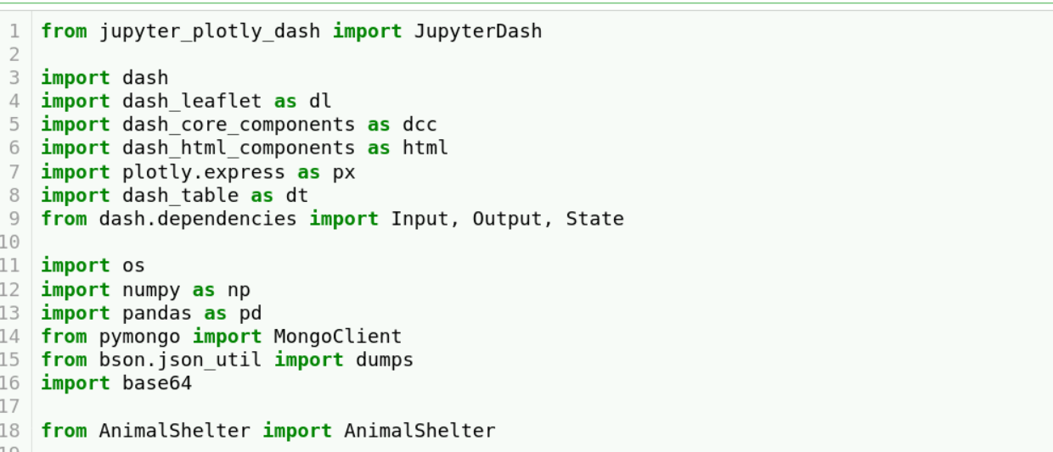

Next, instantiate AnimalShelter with your username and password and create the data frame.

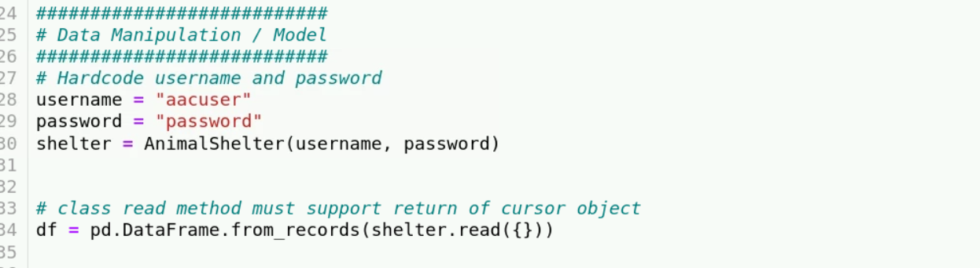

Create a JupyterDash app and setup the logo image.

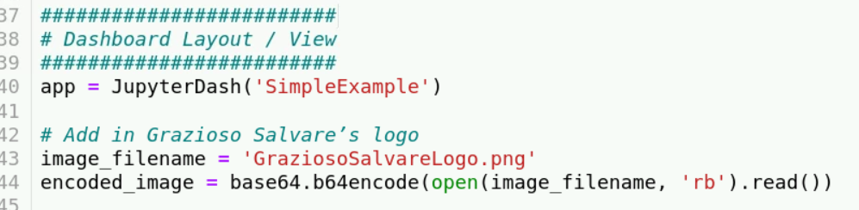

Begin setting up the dashboard. At the top, include any headers and the logo. Format the logo and create the URL anchor tag to [www.snhu.edu](http://www.snhu.edu).

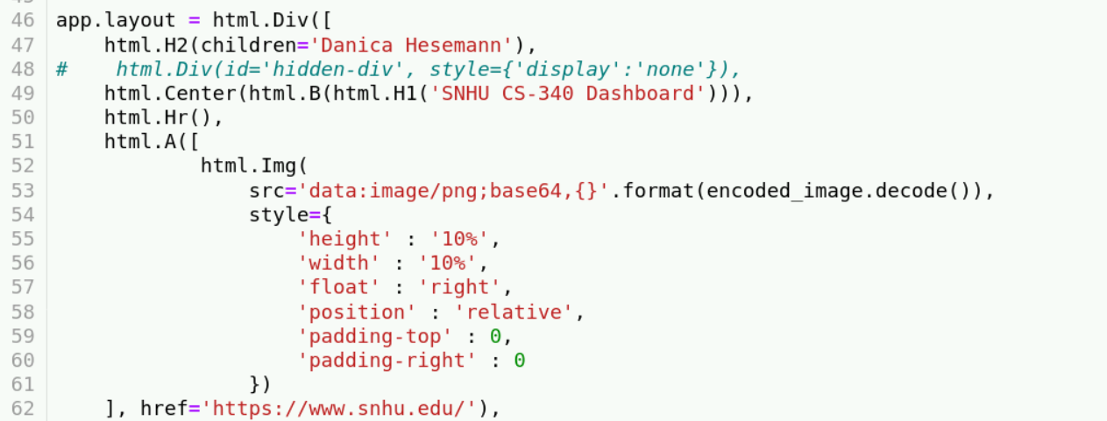

Define the labels and values for each radio item and set the default to “Reset” to automatically display an unfiltered list.

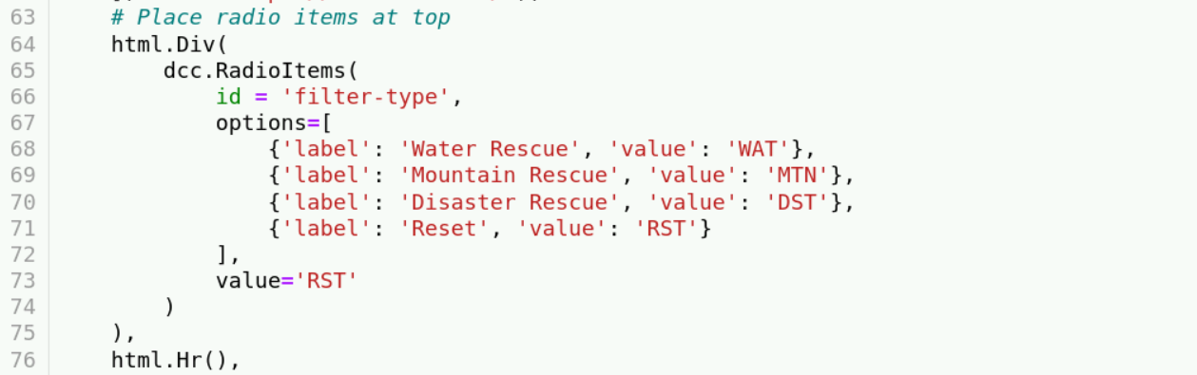

Create the data table and tailor it to its users.

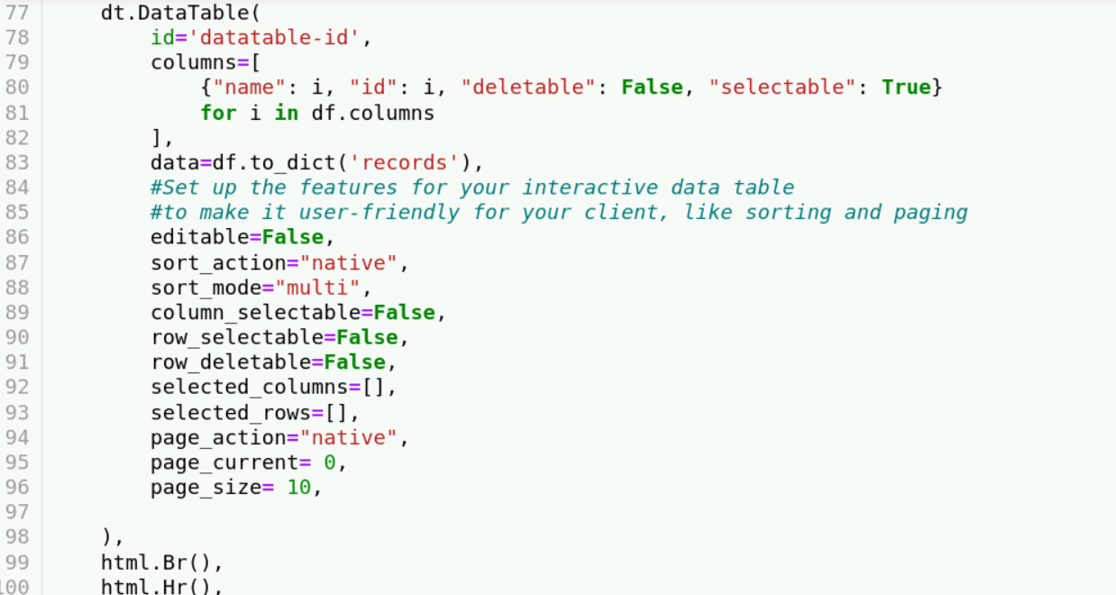

Set up the charts side by side.

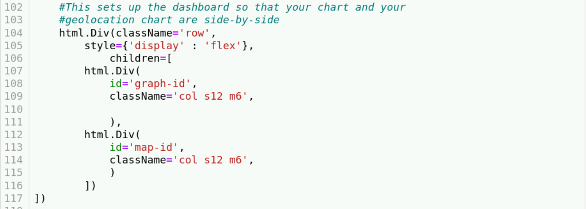

Set up the interactive filters using dash callbacks (more information: <https://dash.plotly.com/basic-callbacks>). Update the data frame depending on the value of the selected radio item. For the “Reset” filter, read every entry in the database. The data frame can be updated by reading in a list of animals obtained by forming queries. Since preferred animals are determined by breed, sex, and age ranges (in weeks), queries should use those key value pairs. You can read multiple breeds using the $in operator followed by a list of the breeds to select. An age range can be defined using the $gte and $lte operators.

The preferred breeds for water rescue are Labrador Retriever Mix, Chesapeake Bay Retriever, and Newfoundland, the preferred sex is intact female, and the preferred age range is 26-156 weeks.

The preferred breeds for mountain and wilderness rescue are German Shepherd, Alaskan Malamute, Old English Sheepdog, Siberian Husky, and Rottweiler, the preferred sex is intact male, and the preferred age range is 26-156 weeks.

The preferred breeds for disaster or individual rescue are Doberman Pinscher, German Shepherd, Golden Retriever, Bloodhound, and Rottweiler, the preferred sex is intact male, and the preferred age range is 20-300 weeks.

The queries can be constructed like so:

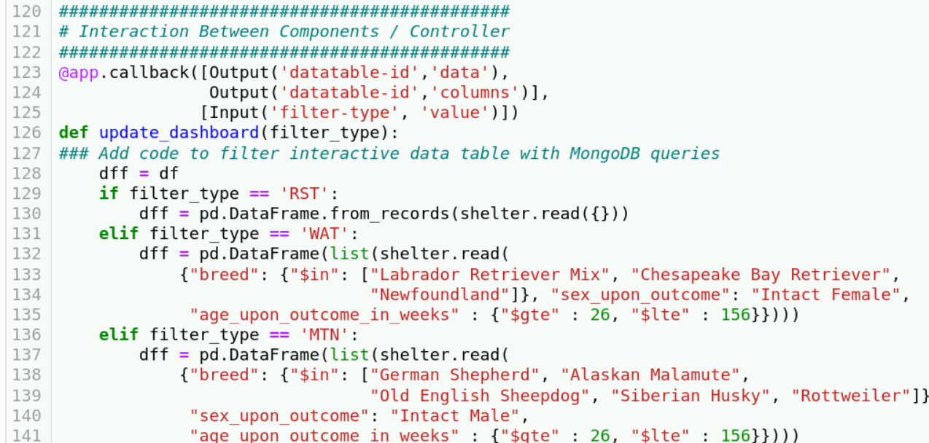 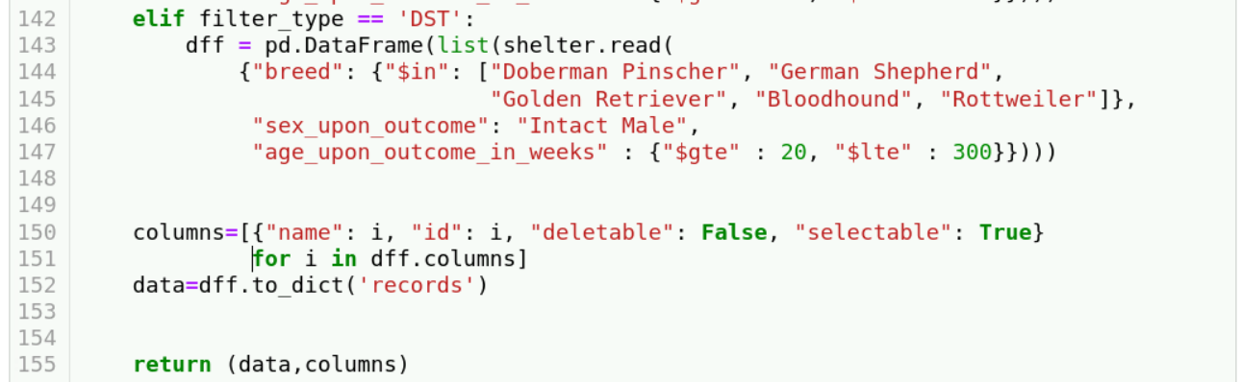

Create a callback to construct a pie chart using plotly express to display the percentage of each breed in the selected data frame. (More information: <https://plotly.com/python-api-reference/generated/plotly.express.pie>, <https://plotly.com/python/pie-charts/>)

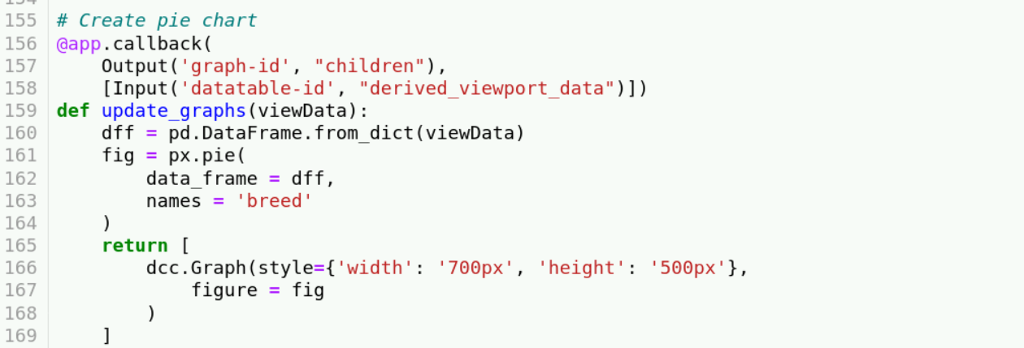

Finally, create a callback to construct a geolocation chart to display the location of the first result in the data frame.

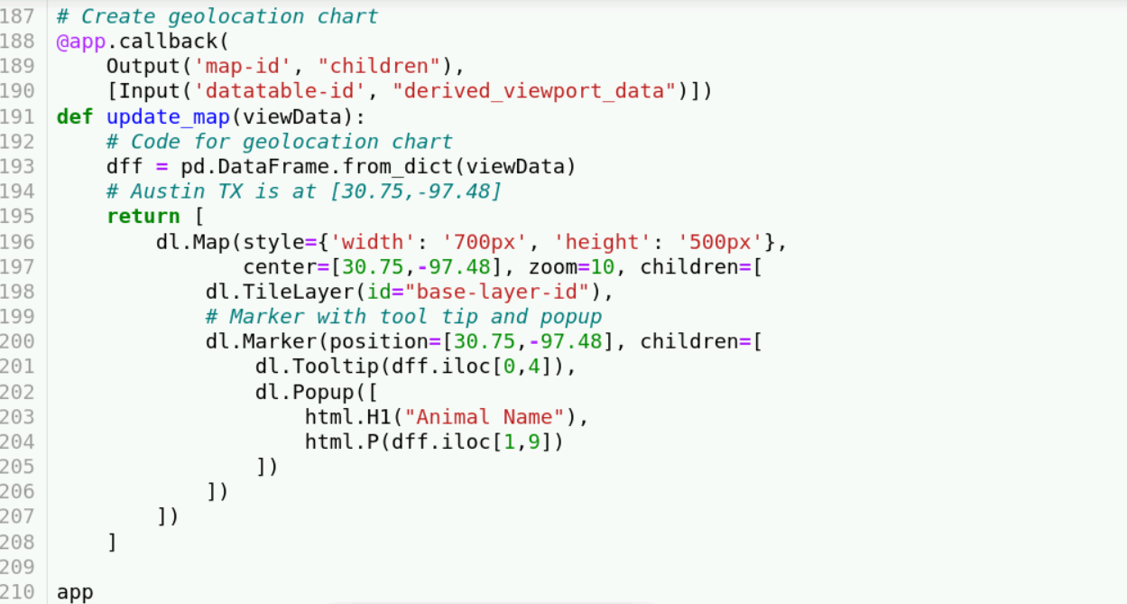

**Installation**

To access the database and use the AnimalShelter Python module, it is necessary to have MongoDB installed, which can be purchased/downloaded from <https://www.mongodb.com/>. PyMongo, a Python driver for MongoDB that allows users to make queries to a MongoDB database using Python, can be installed with the command:

$ python -m pip install pymongo.

(More information at <https://pymongo.readthedocs.io/en/stable/>).

The dashboard was created using Dash, a Python framework used to build interactive data visualization apps. Information on installing dash can be found at <https://dash.plotly.com/installation>.

**Usage**

When you run the code and bring up the dashboard, it will display the unfiltered data table of animals in the database, followed by the pie chart and geolocation chart.

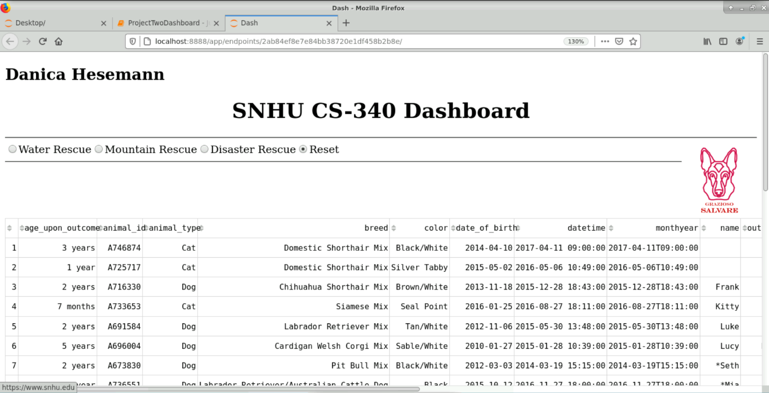 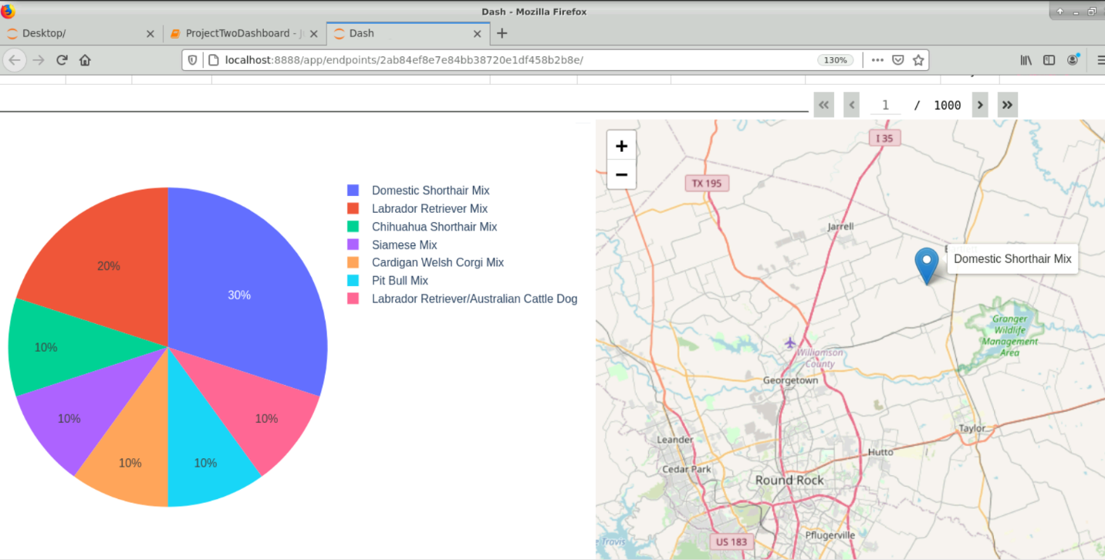

Clicking on the logo in the dashboard, located in the upper right corner, it will open a browser to the SNHU website.

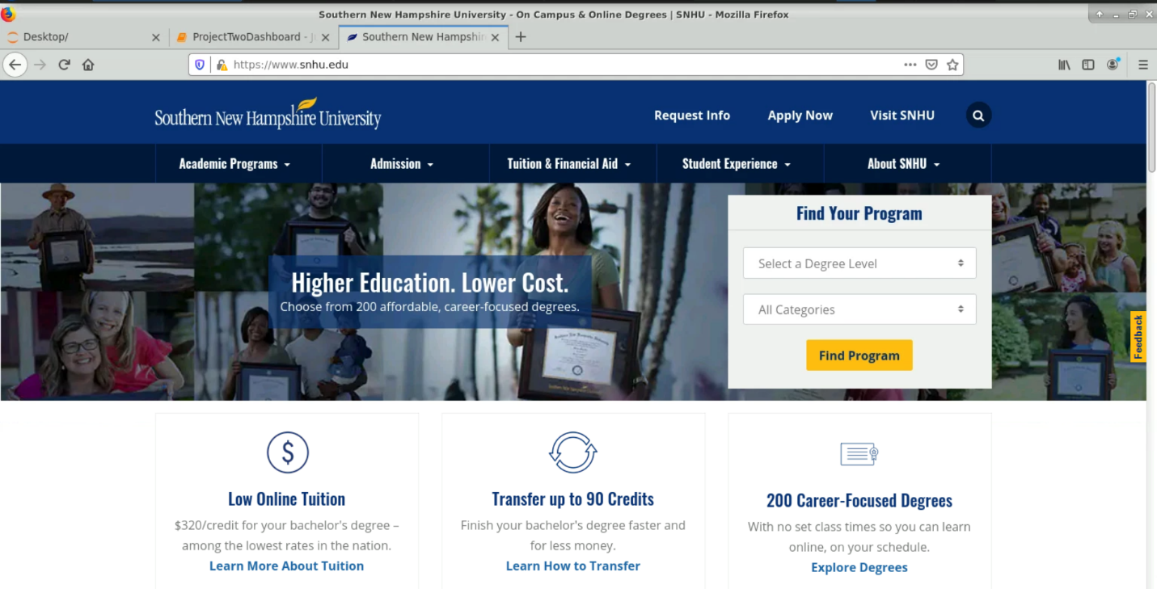

The data table, pie chart, and geolocation chart will change dynamically when a different radio item is selected. Here is the result when selecting Water Rescue:

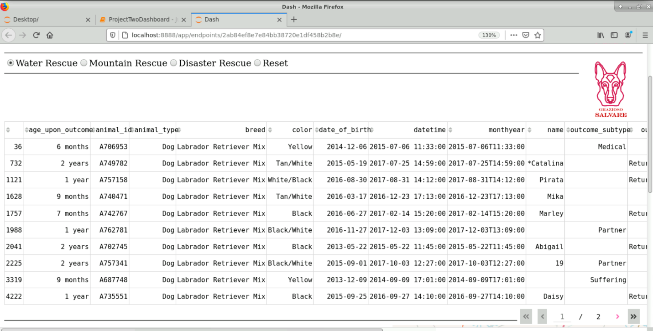

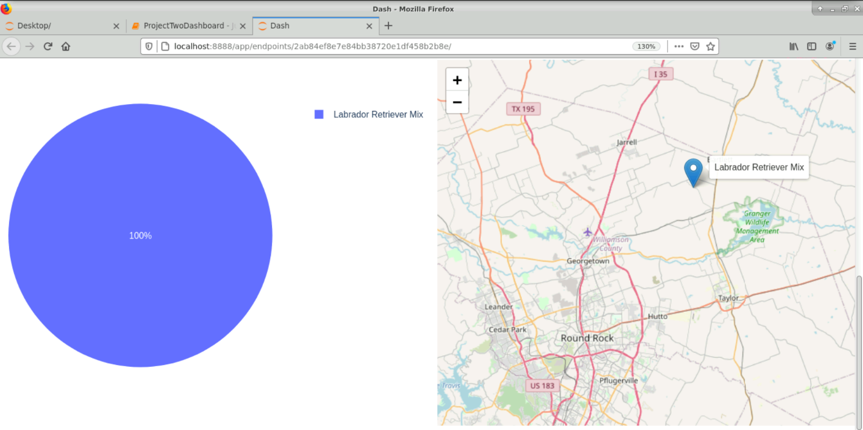

Disaster Rescue:

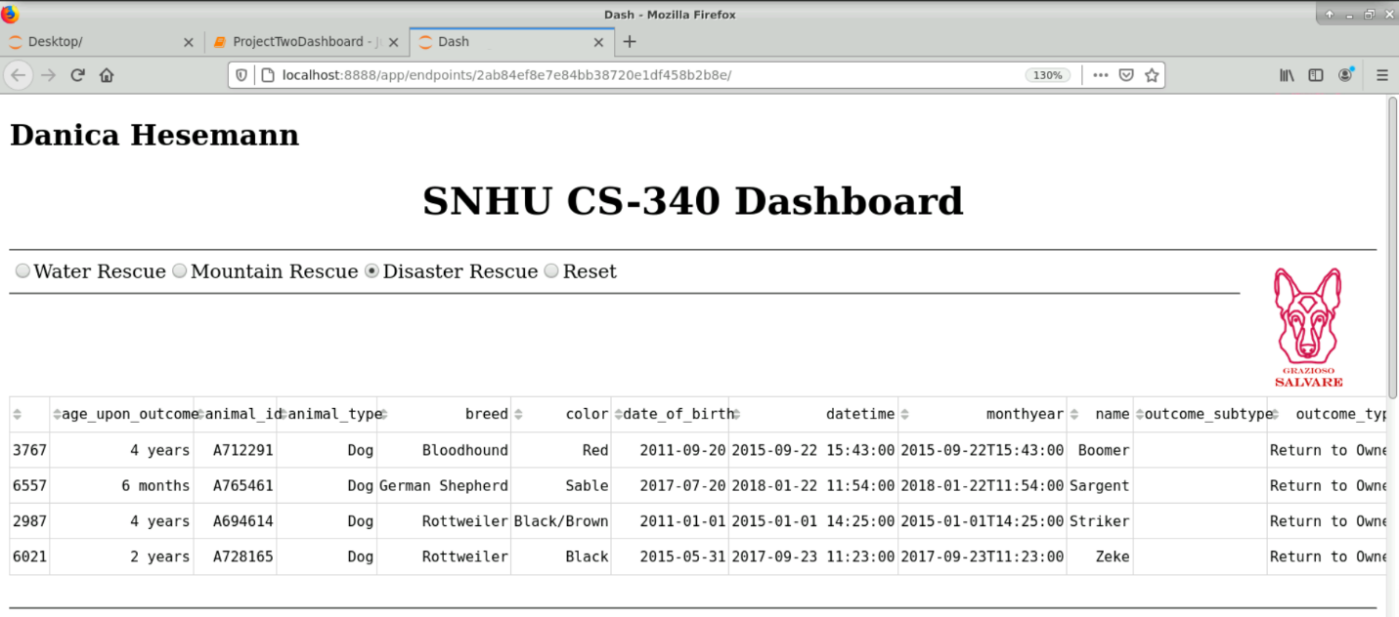

A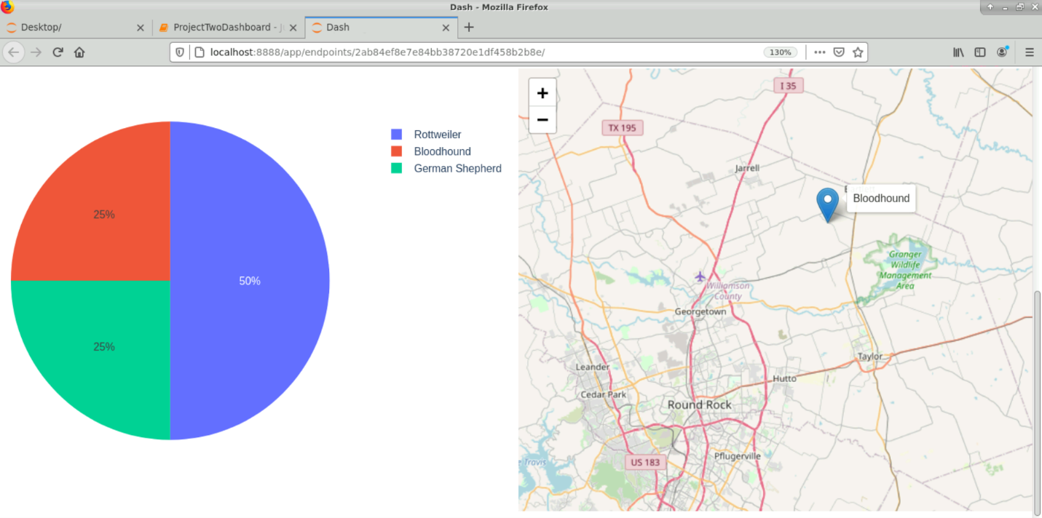

And Mountain Rescue:

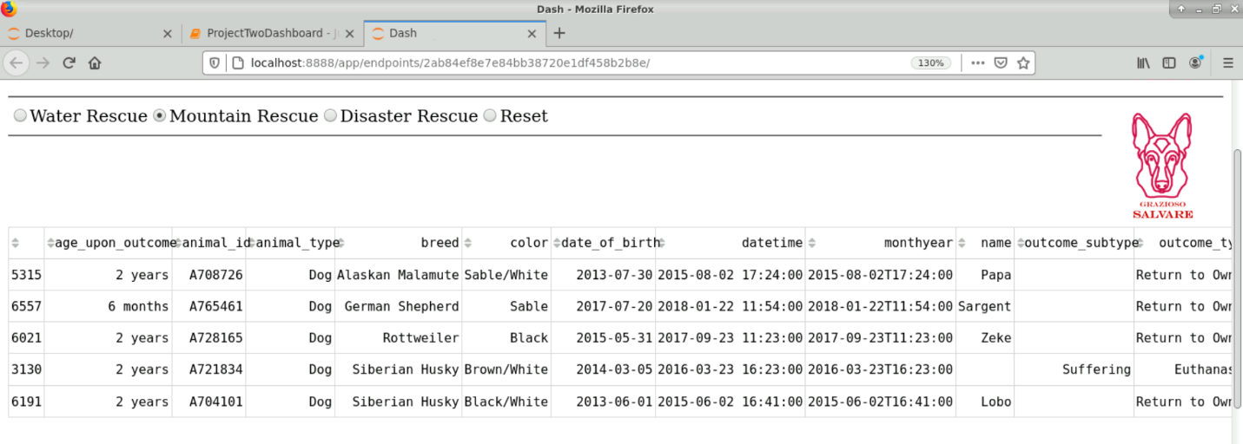

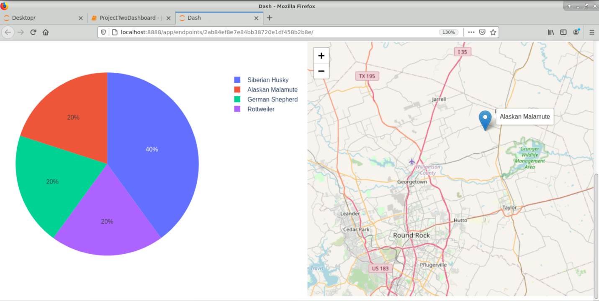

**Contact**

Danica Hesemann